2.3 Brainstorming Template

Step-1: Team Gathering, Collaboration and Select the Problem Statement
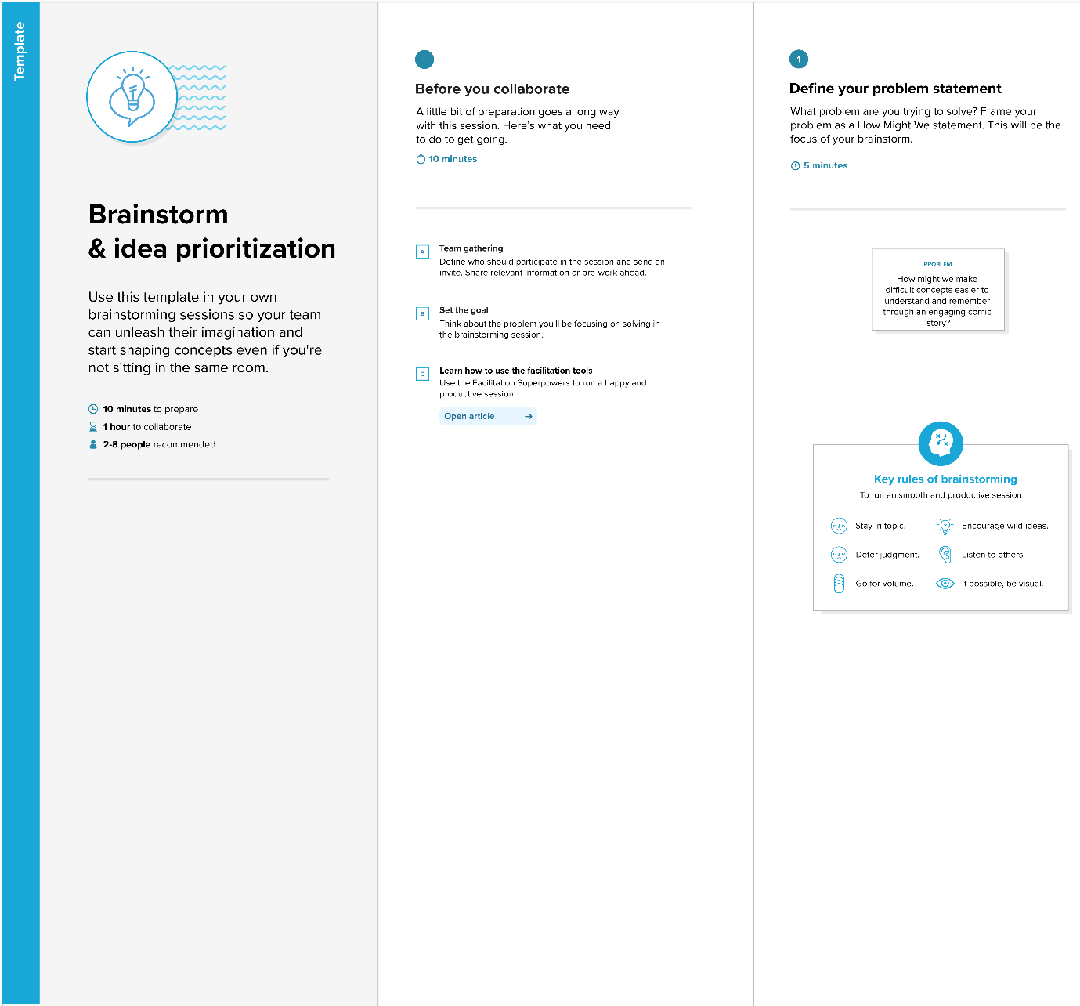
Brainstorming – Step 1

Step-2: Brainstorm, Idea Listing and Grouping
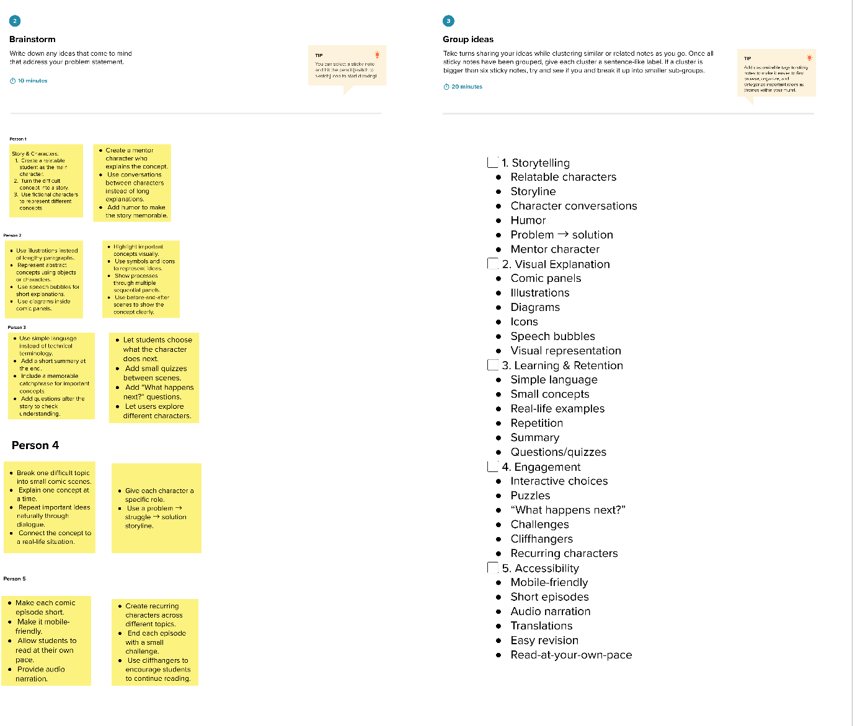
Brainstorming – Step 2

Step-3: Idea Prioritization
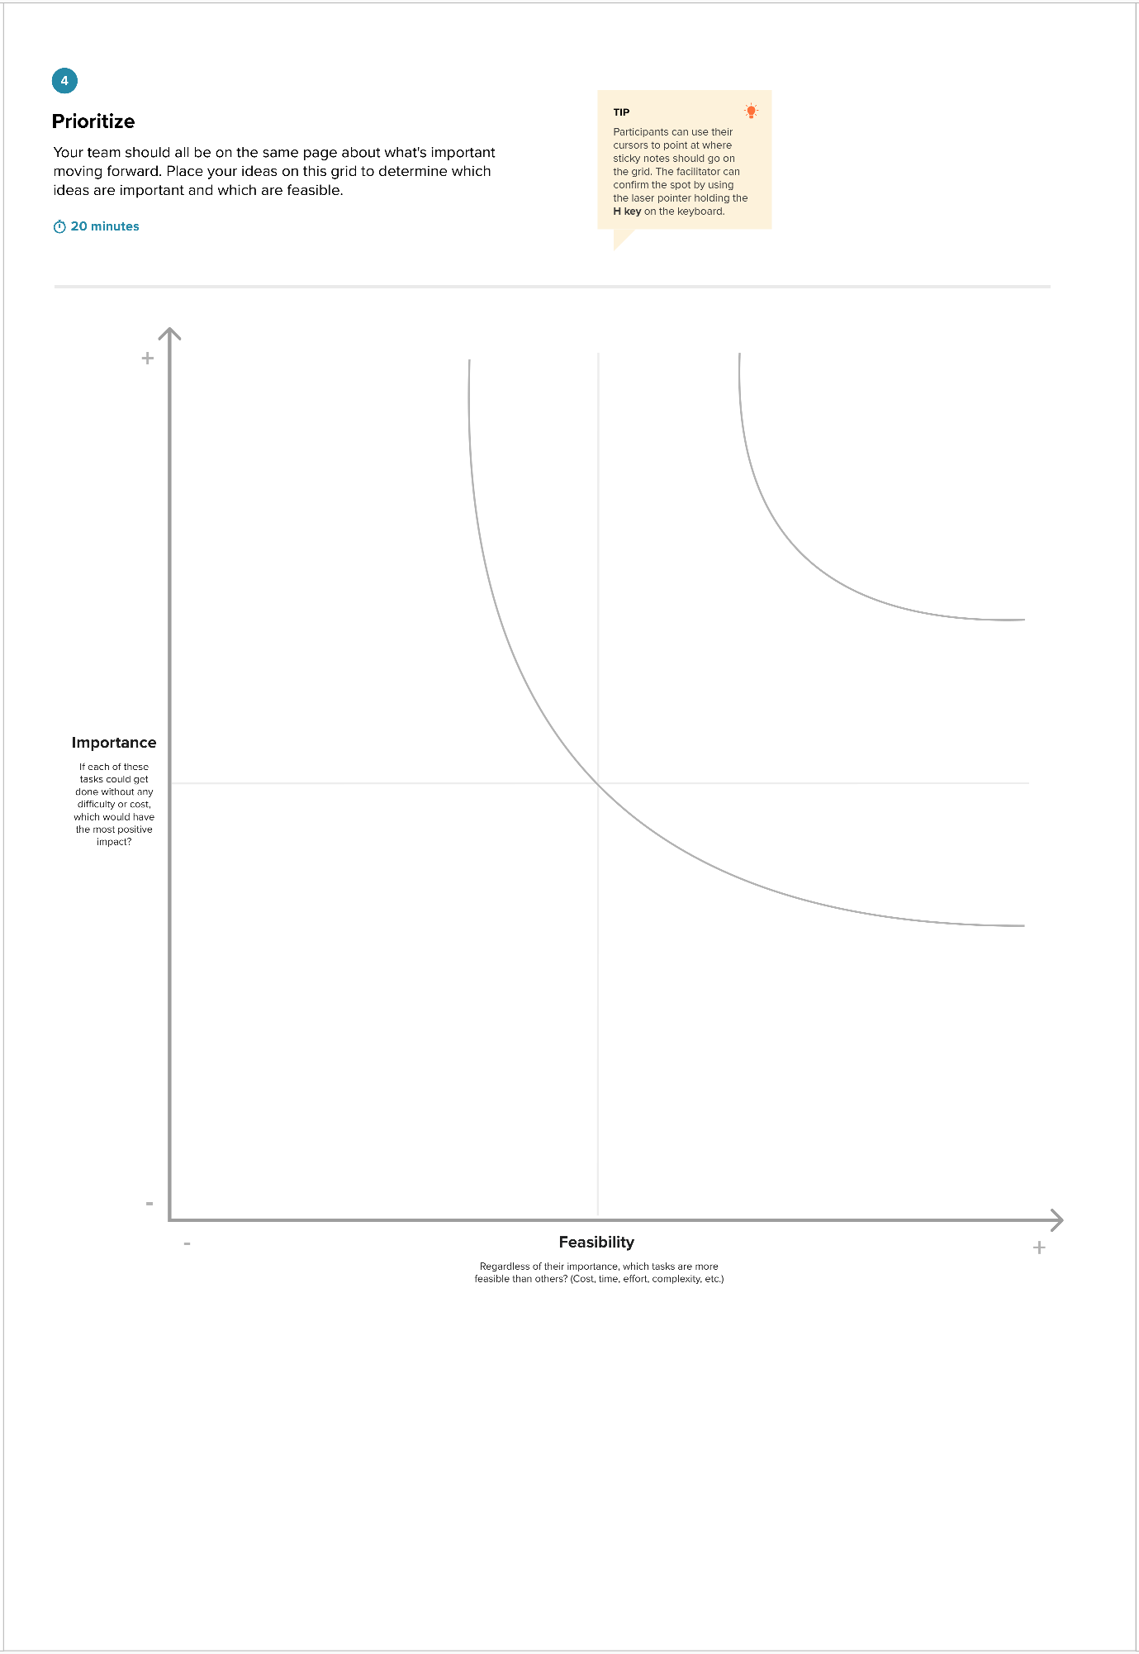
Idea Prioritization

